**Configure VPN between Mumbai and Ohio – Lab 2 of 4**

In mumbai region, Click “EC2”

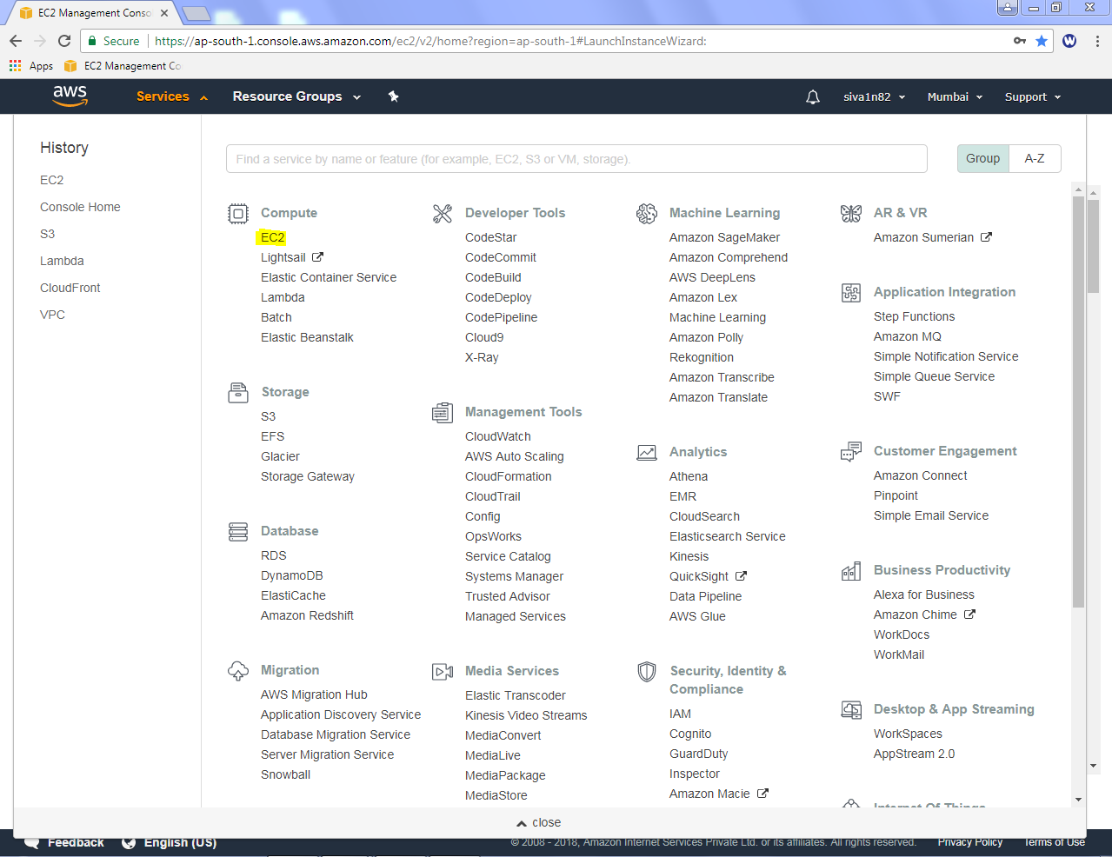

Click “Launch Instance”.

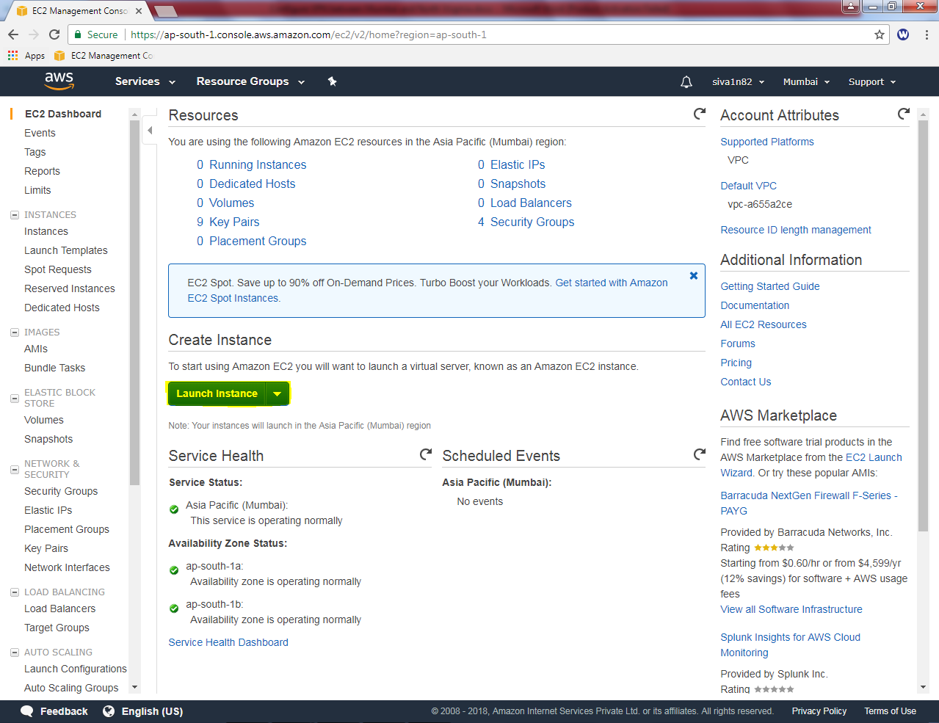

Select “Amazon Linux”

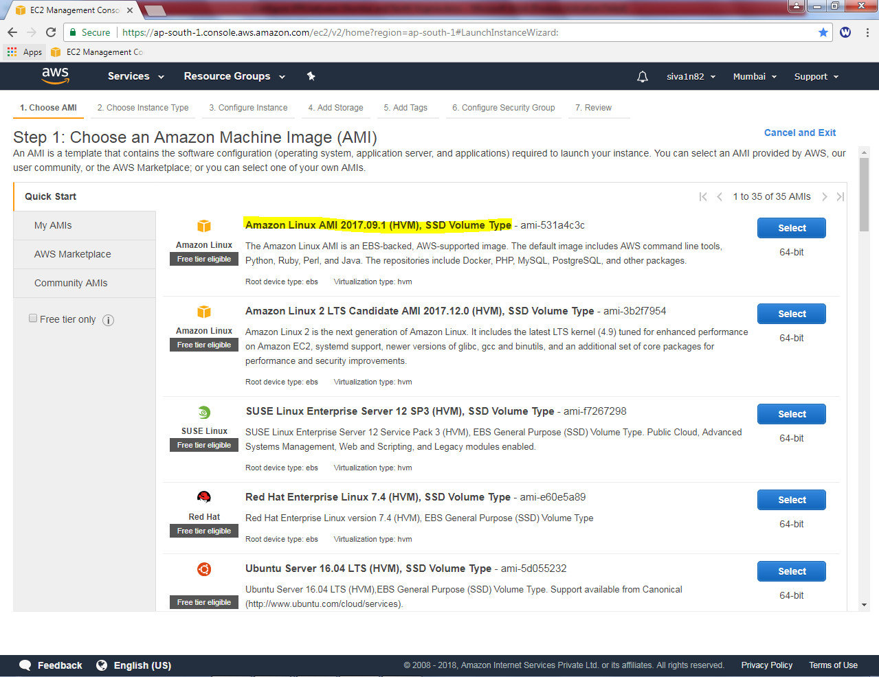

Select General purpose “t2.micro”.

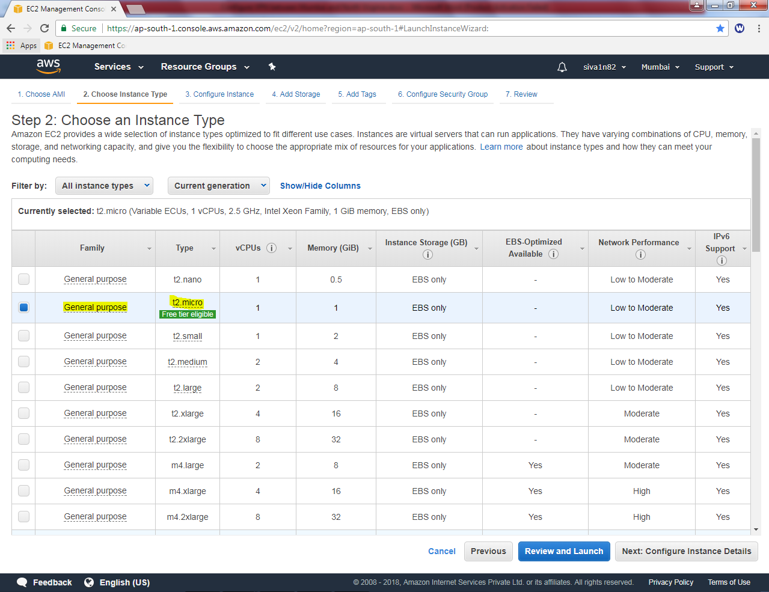

Click “Next”.

In Network, select Sansbound_VPC_Mumbai

Subnet, select Sansbound_Mumbai_Public_subnet

Auto assign Public IP – Disable.

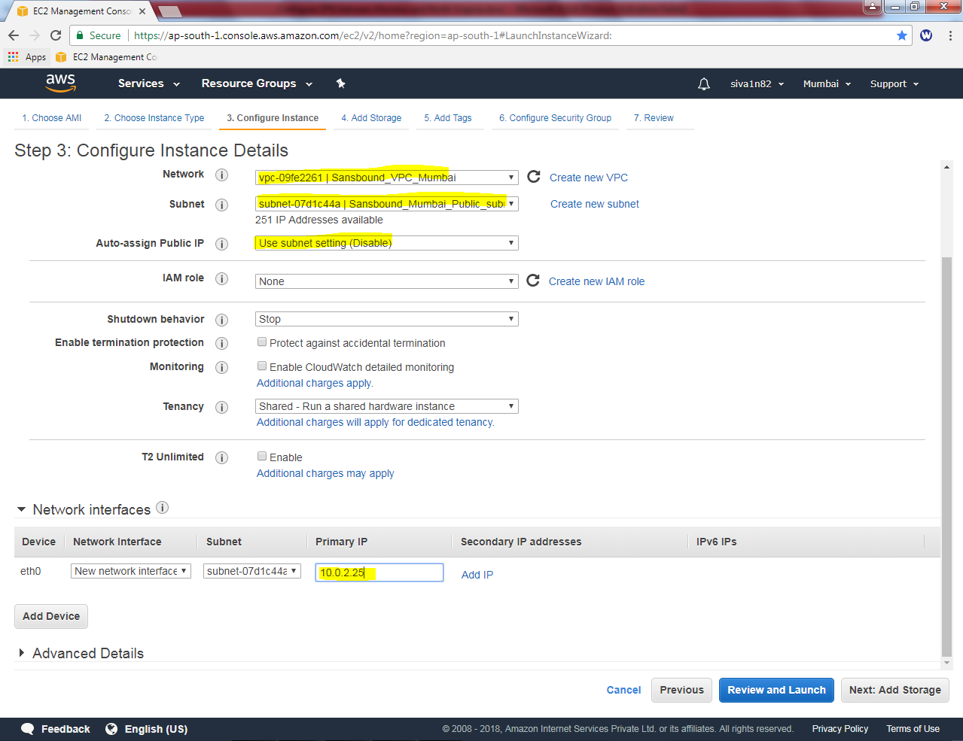

Type the IP of VPN server as 10.0.2.25 and click “Next”.

Leave default settings and click “next”.

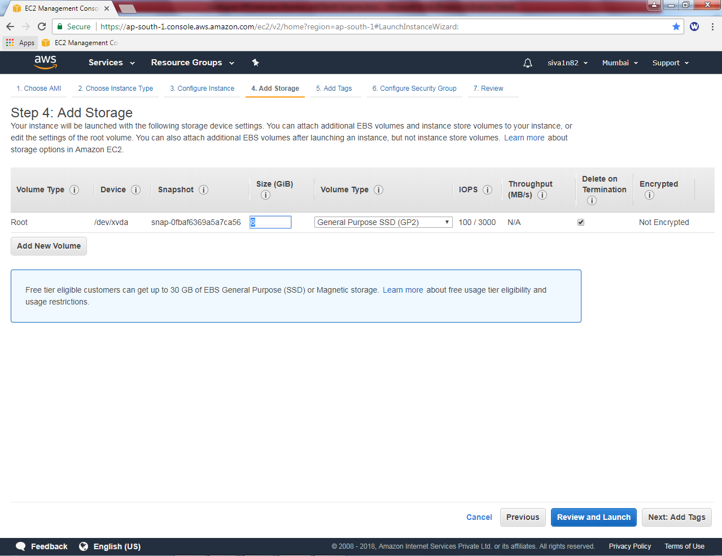

.

Name: Linux VPN Server Mumbai

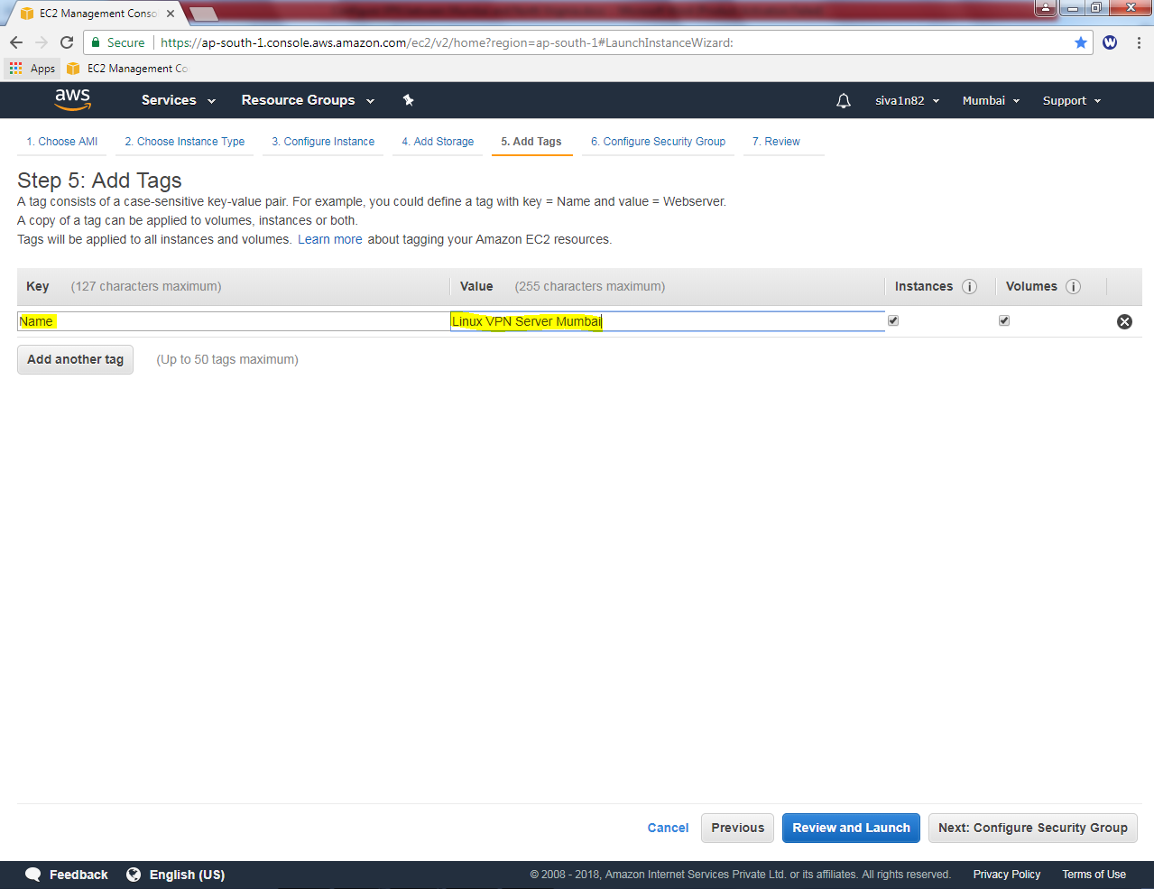

Click “Next”.

Create a new Security Group Name : Mumbai_Linux_Sec_Group

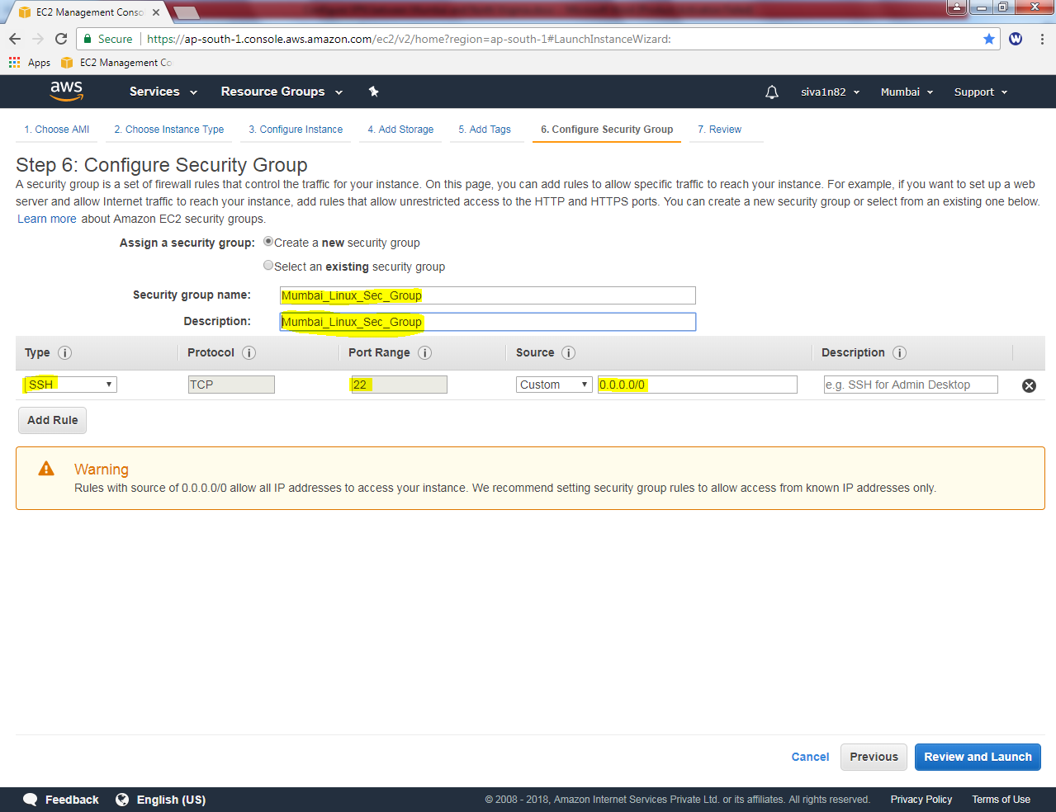

Allow 22 port as default. Click Review and Launch.

Click “Launch”.

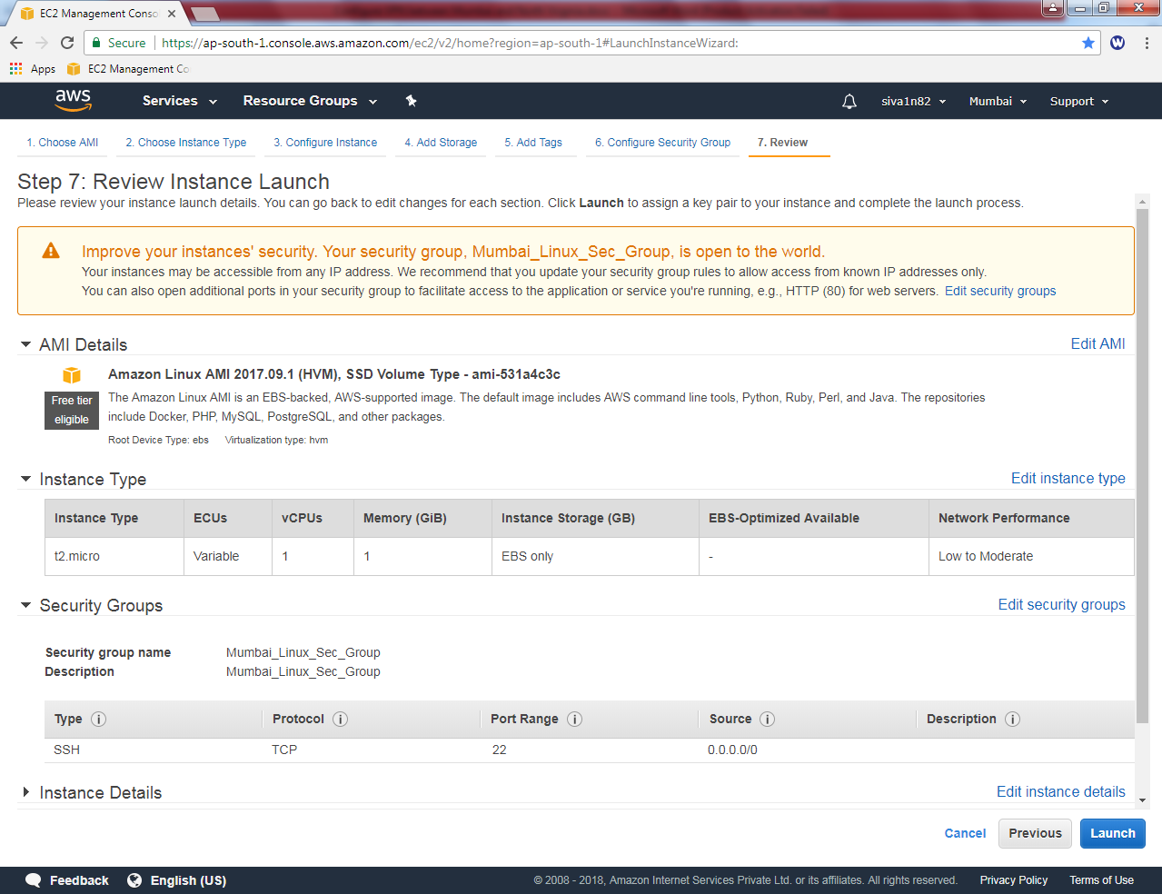

Click choose an existing key pair and select the key.

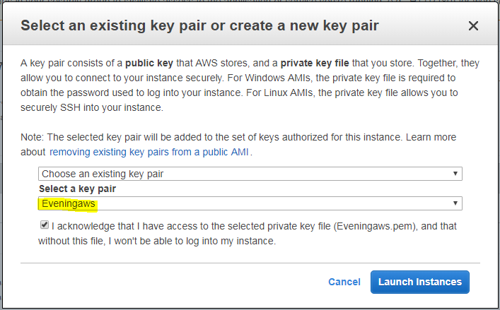

Click “Launch Instances”.

Click the highlighted area to view instance.

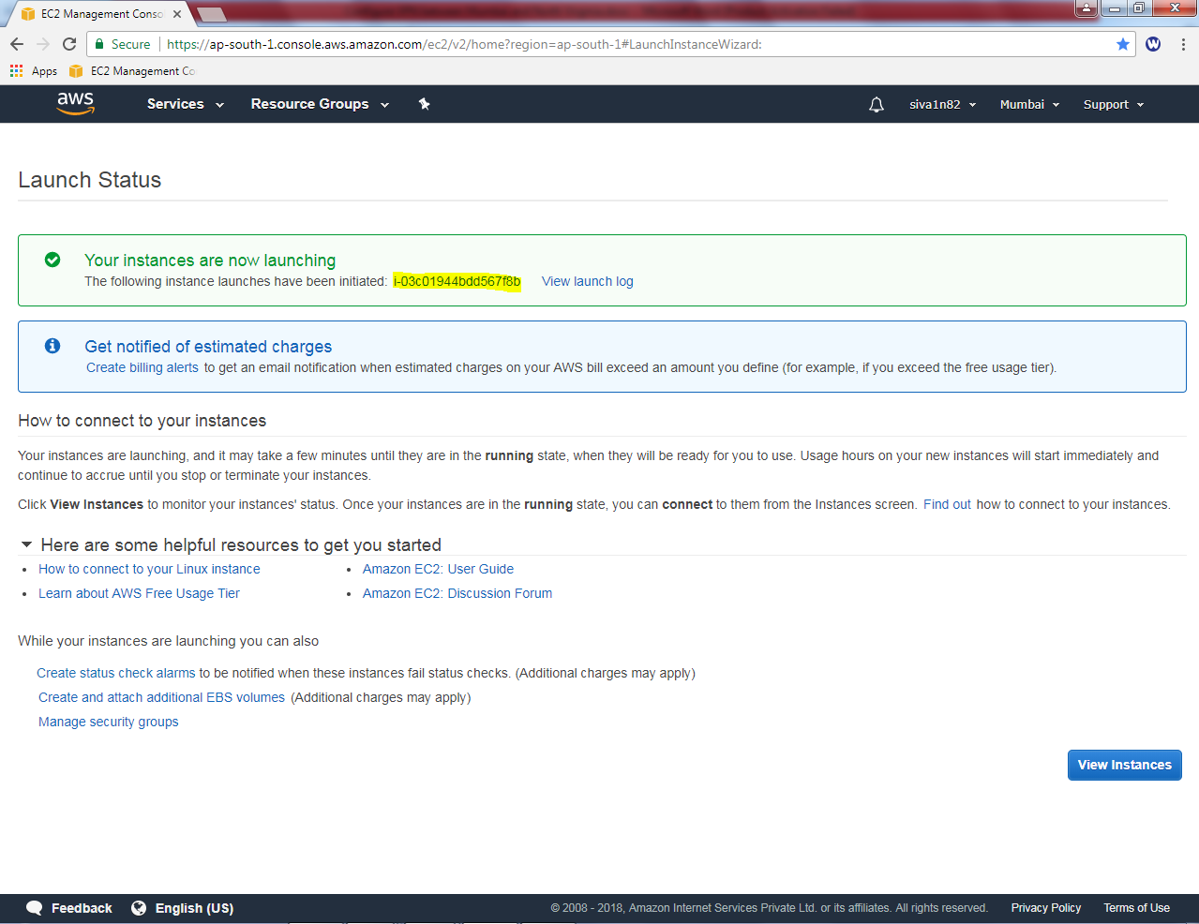

Go to Ohio region, Click “EC2”.

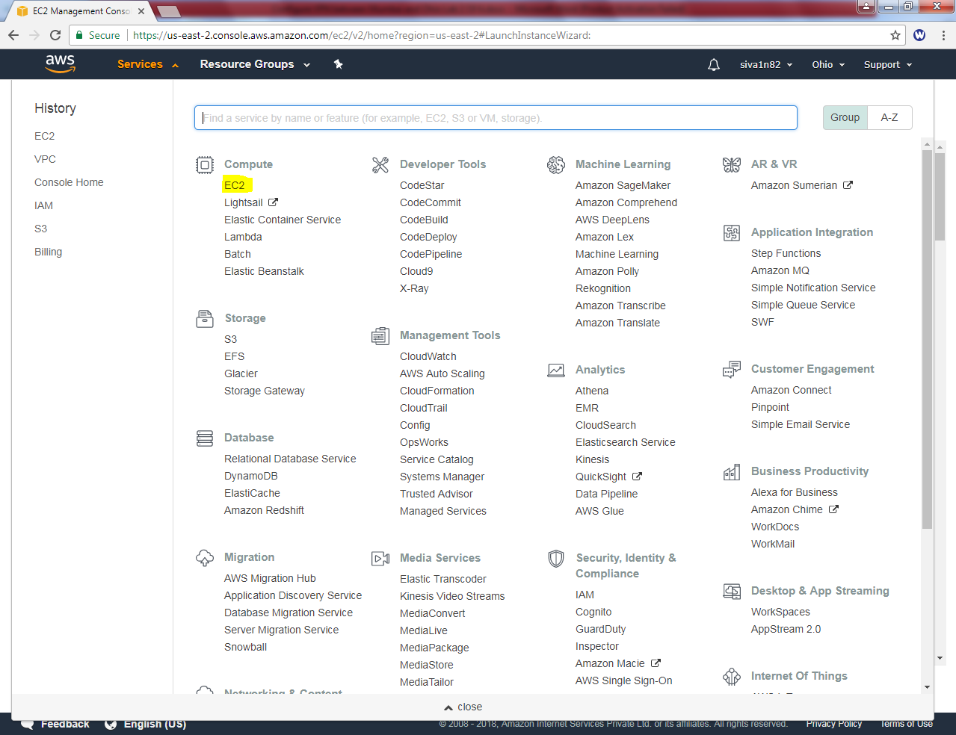

Click “Launch instance”.

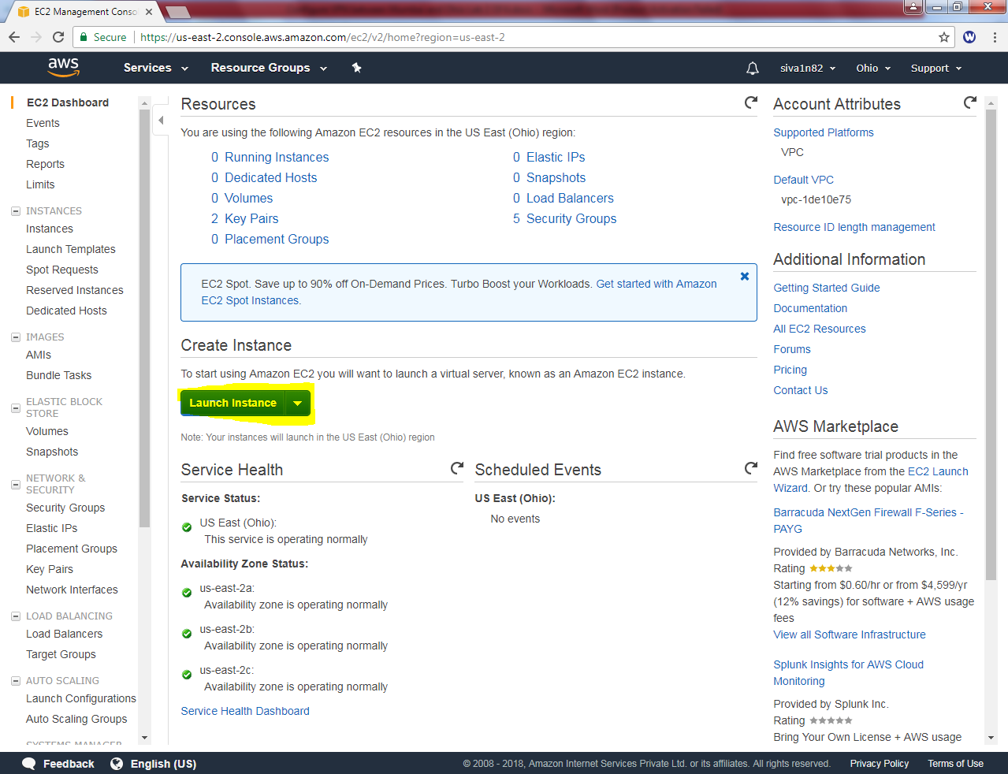

Click “Amazon Linux AMI”.

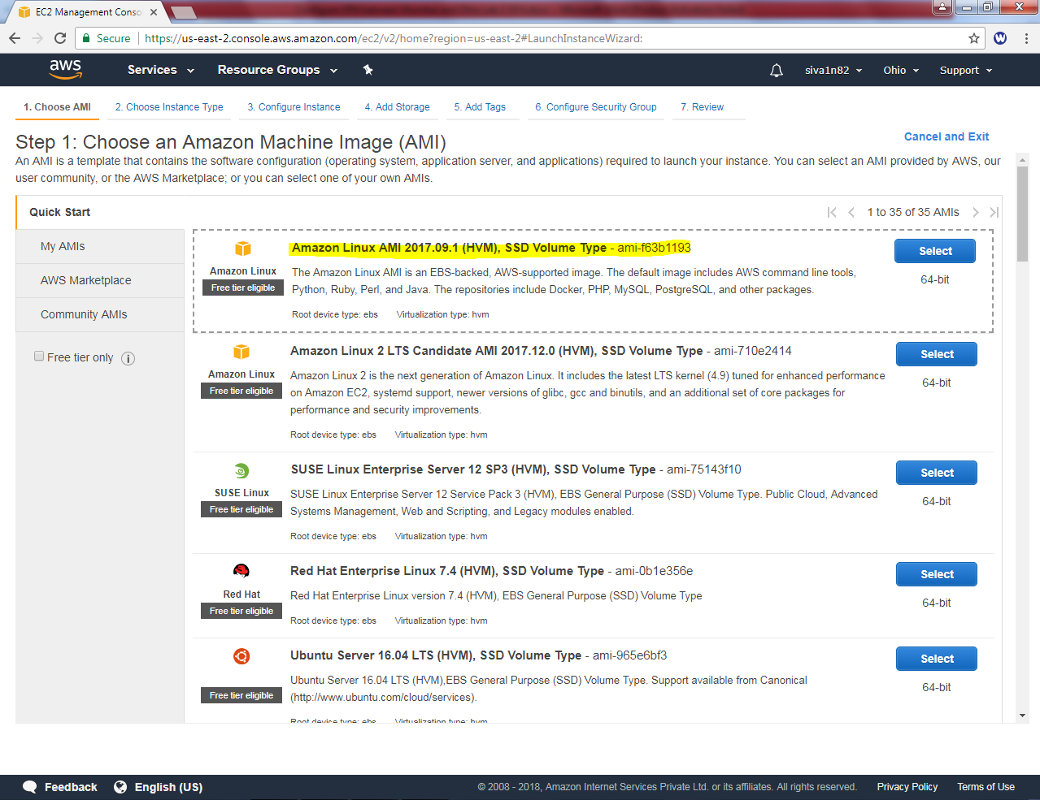

Select General Purpoase (t2.mciro).

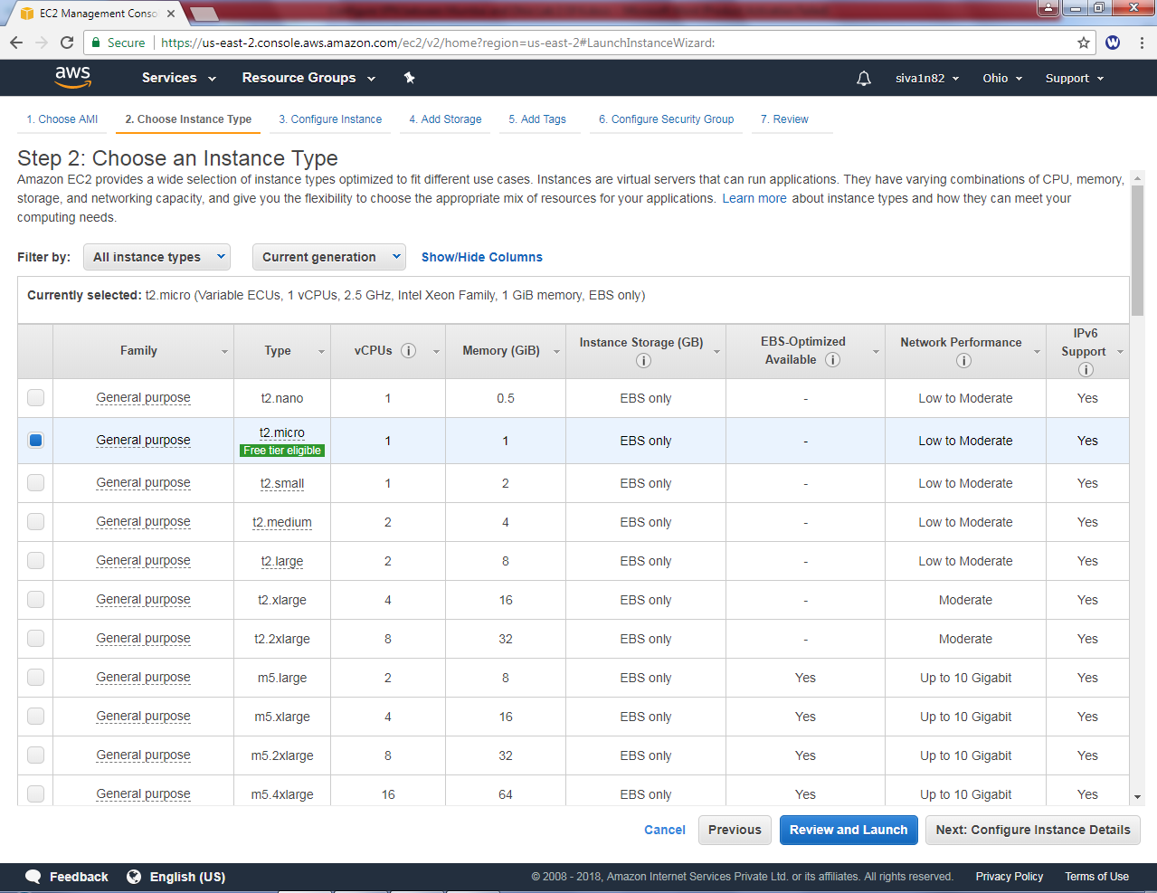

Click “Next”.

Select network as “Sanbound_Ohio_VPC”, subnet as “Sansbound Private Subnet” and Auto-assign Public IP as disable.

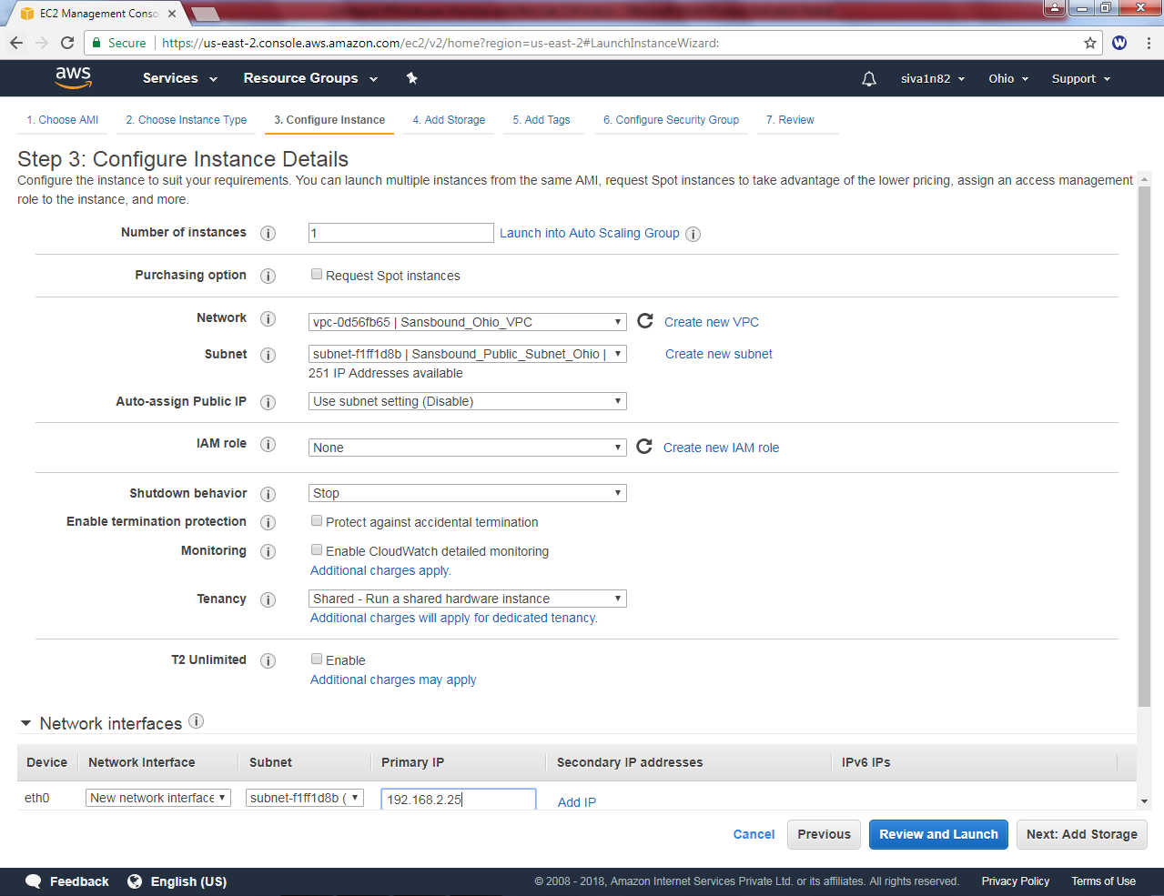

Assign the interface ip as 192.168.2.25 and click ”Next”.

Leave default settings and click “Next”.

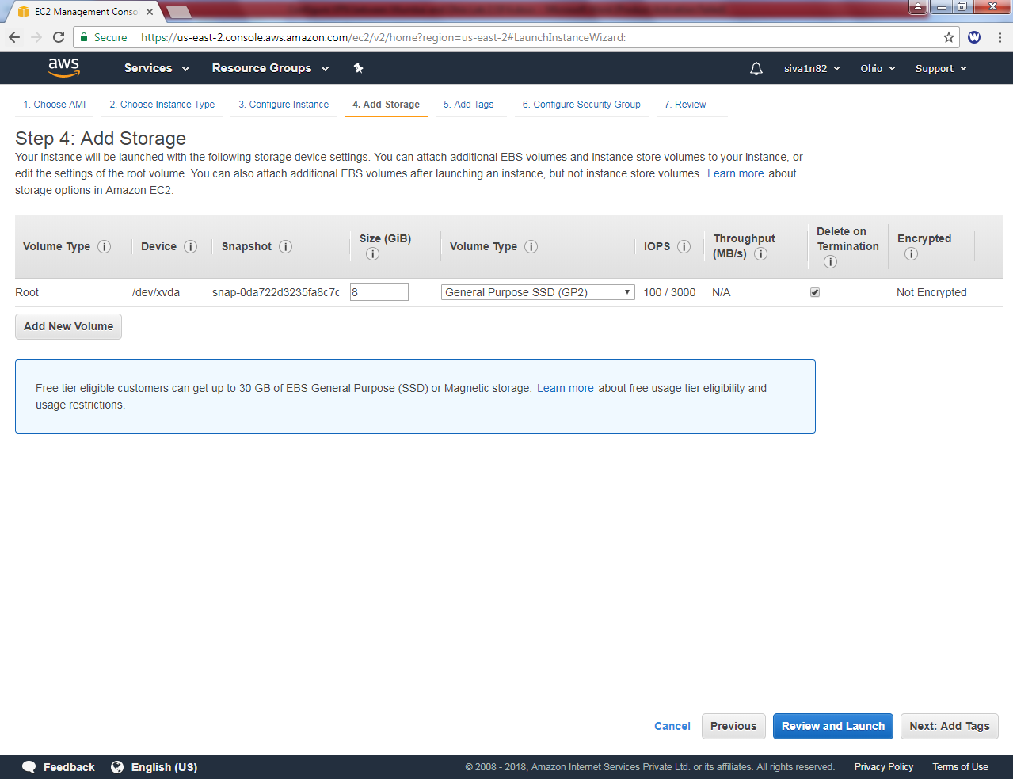

Key as name and Value “VPN Linux Server Ohio”.

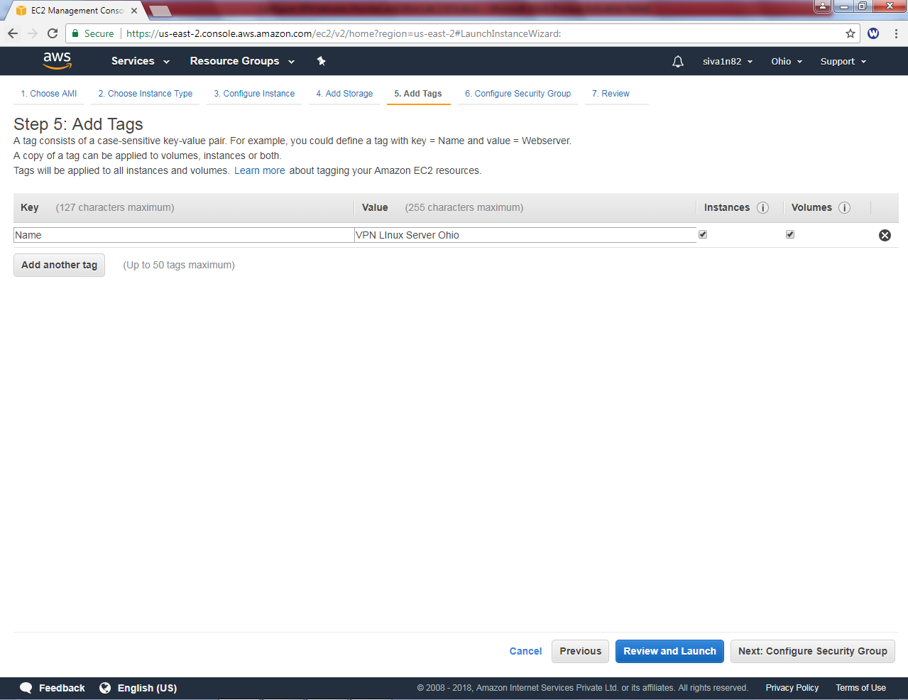

## Click “Next”.

Create a new security group as Ohio_Linux_Sec_Group.

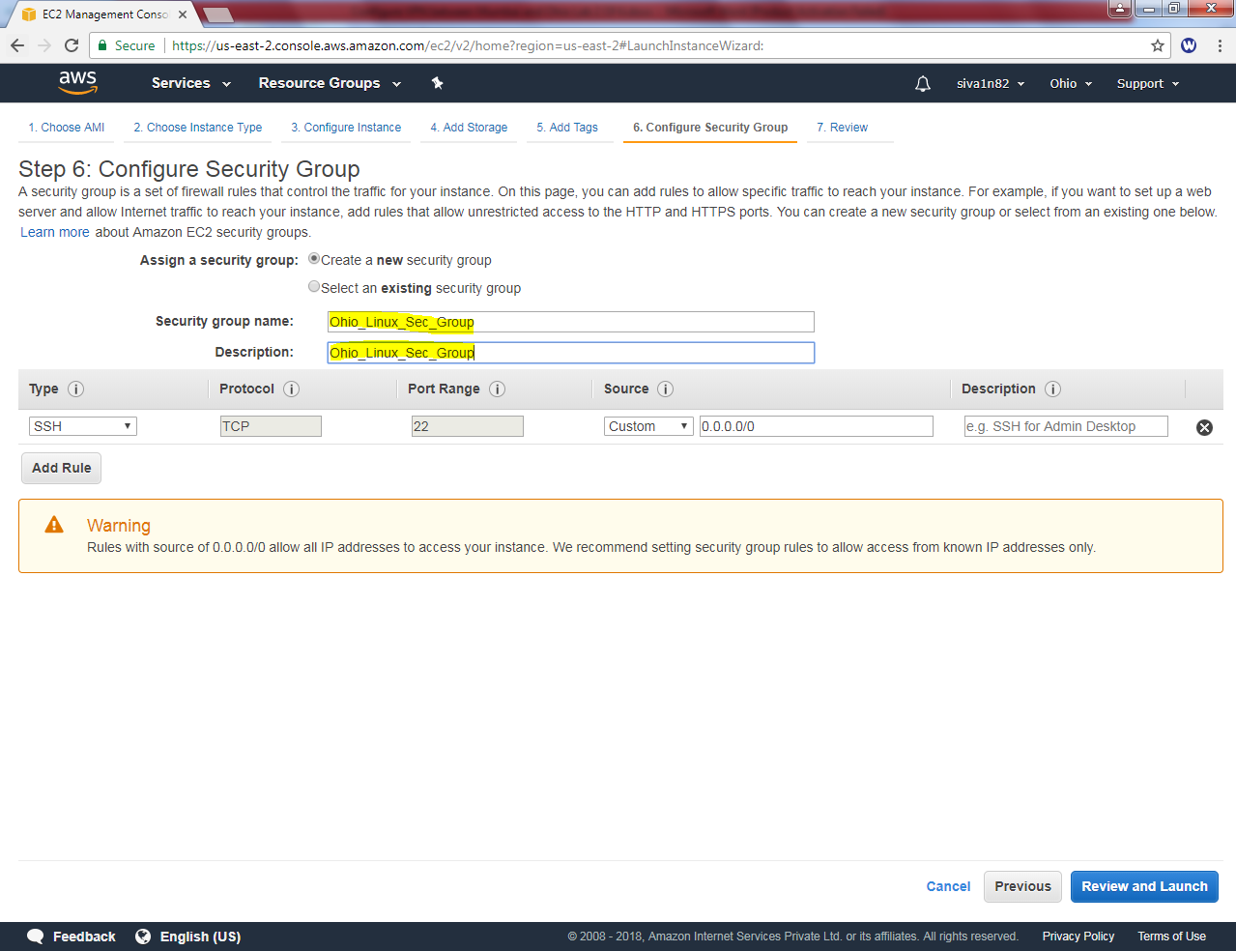

Click “Review and Launch”

Click “Launch”.

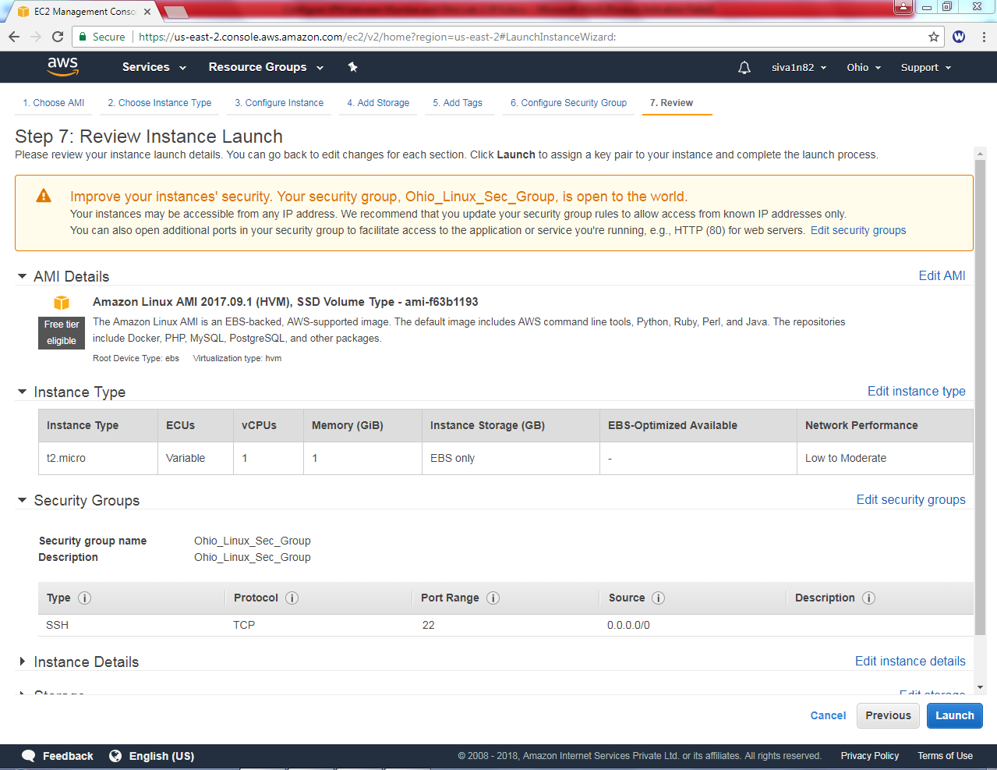

While launch instance, it asks for “Select an existing key pair or create a new key pair”. You can choose an existing key pair and choose the existing key. If you don’t have key need to generate the key.

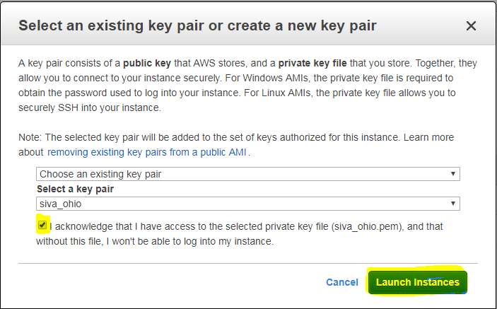

Click “Launch Instance”.

Goto “Mumbai”region.

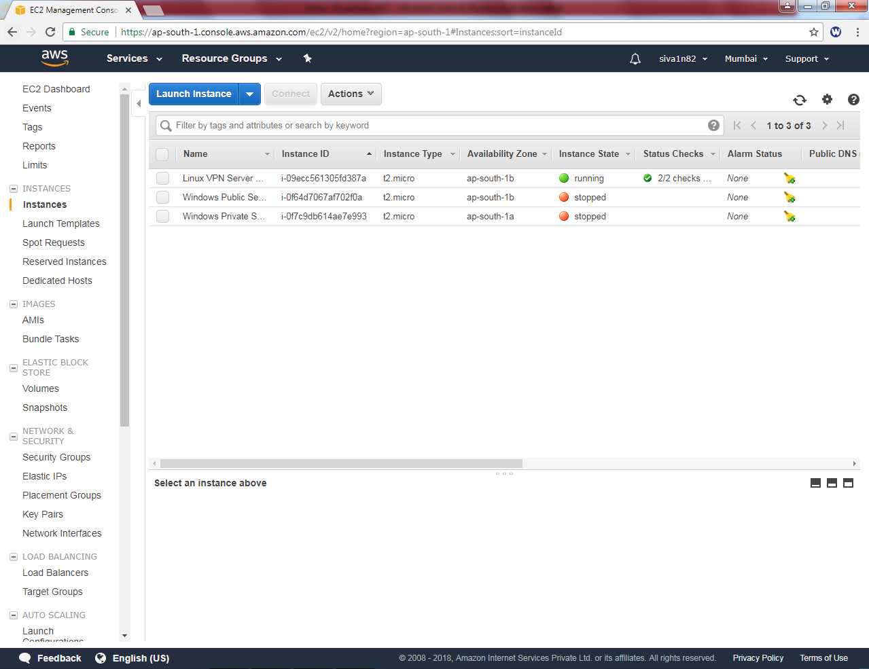

Rename the interface as “Open Swan”.

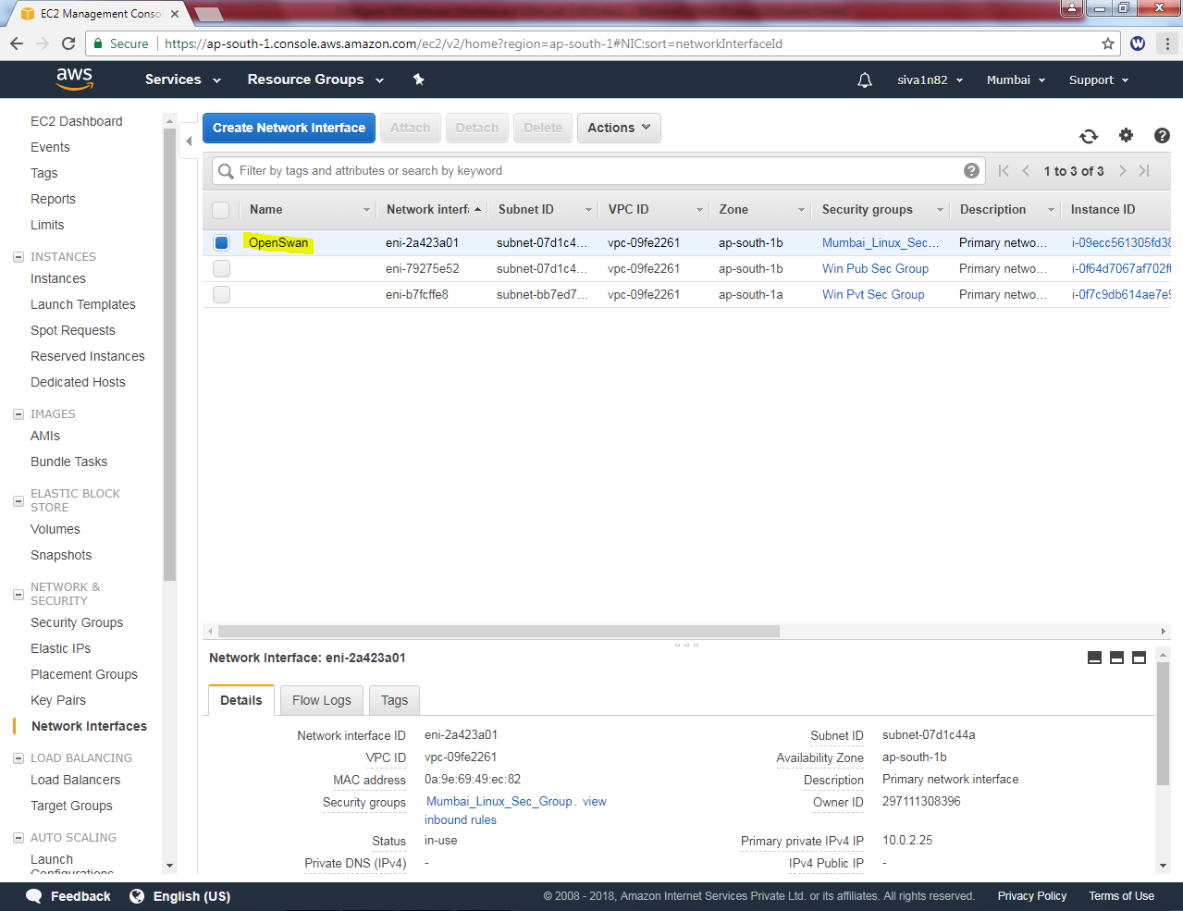

Click “Elastic IP” and then click “Allocate new address”.

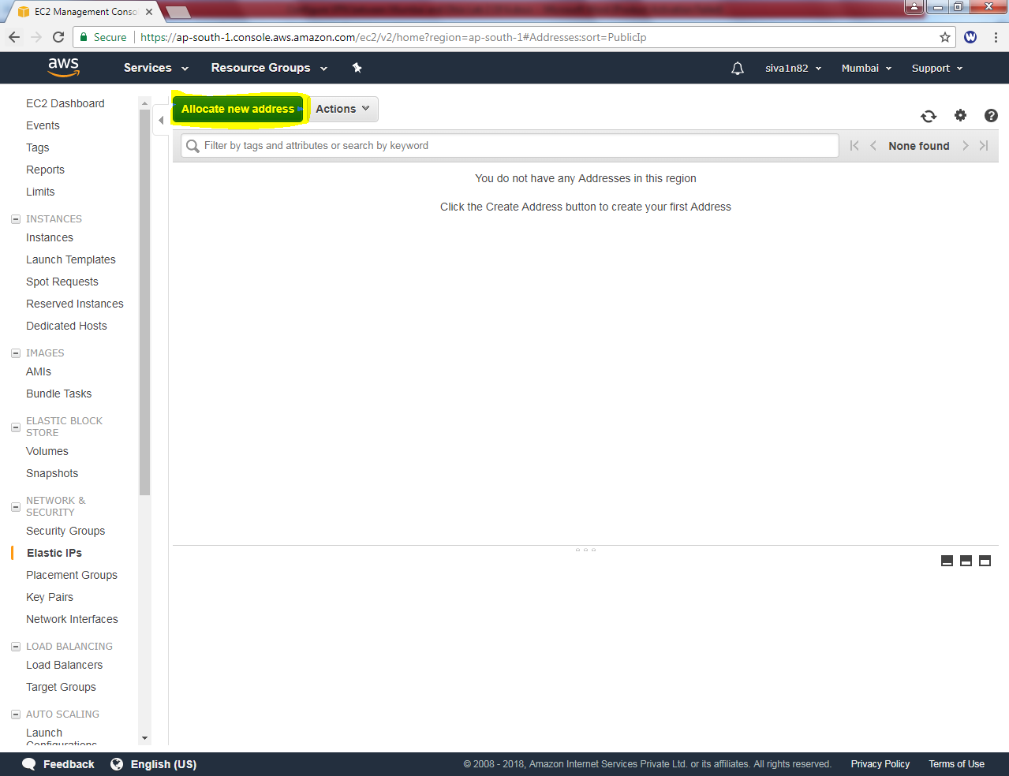

Click “Allocate”.

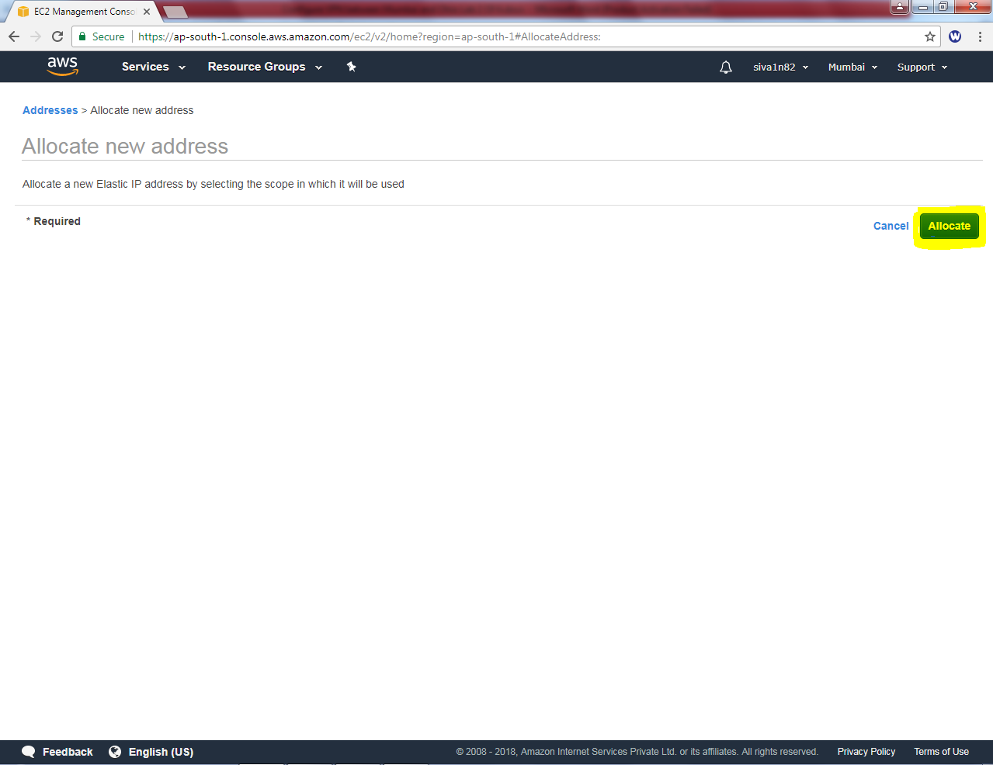

Elastic IP has been assigned in Mumbai region.

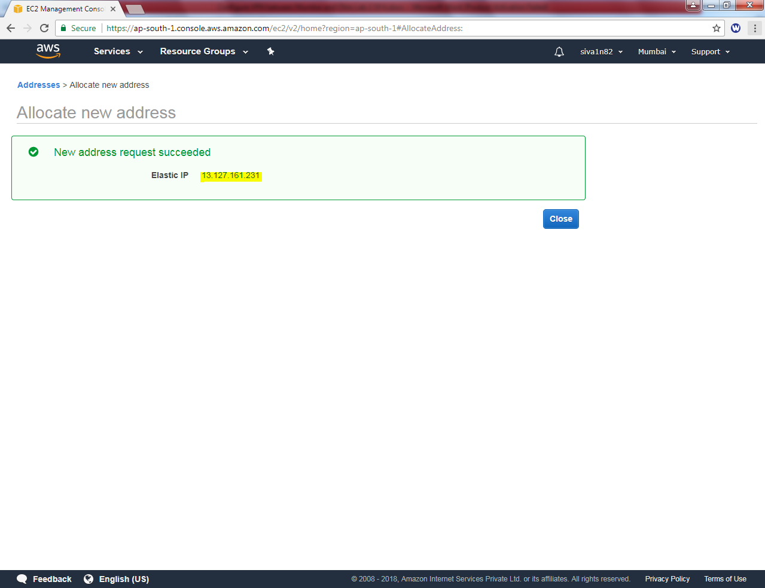

Click “Close”.

Select the Elastic IP and right click Select “Associate address”

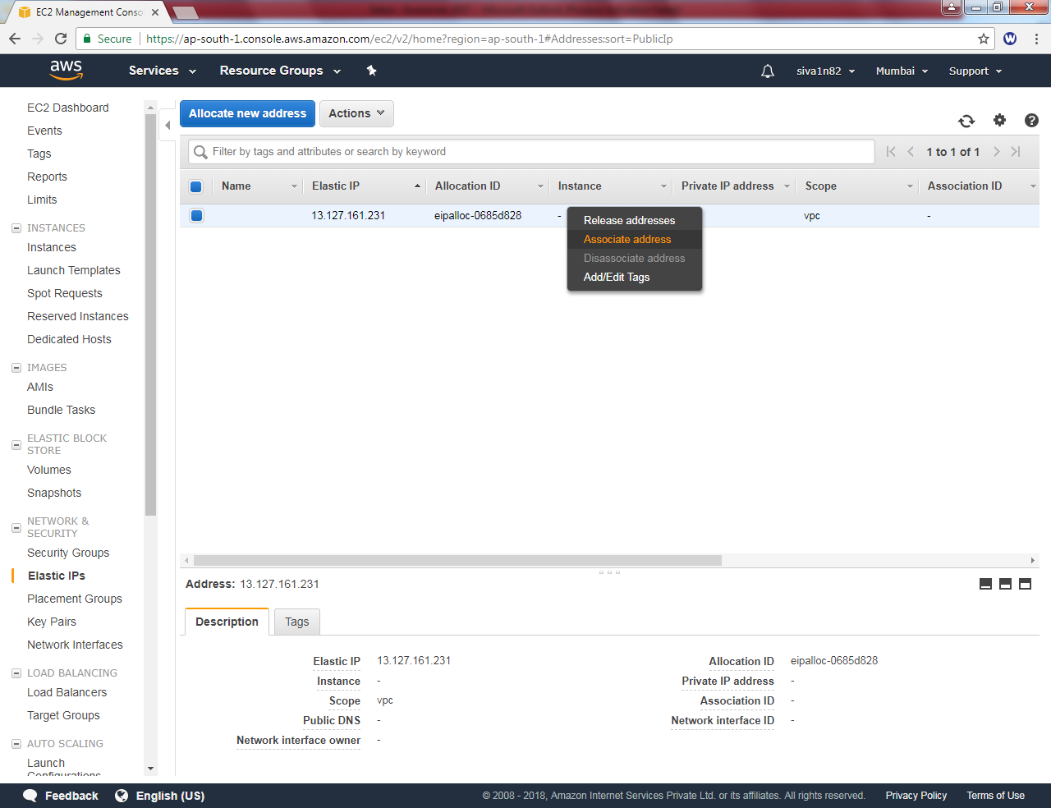

Select the network interface.

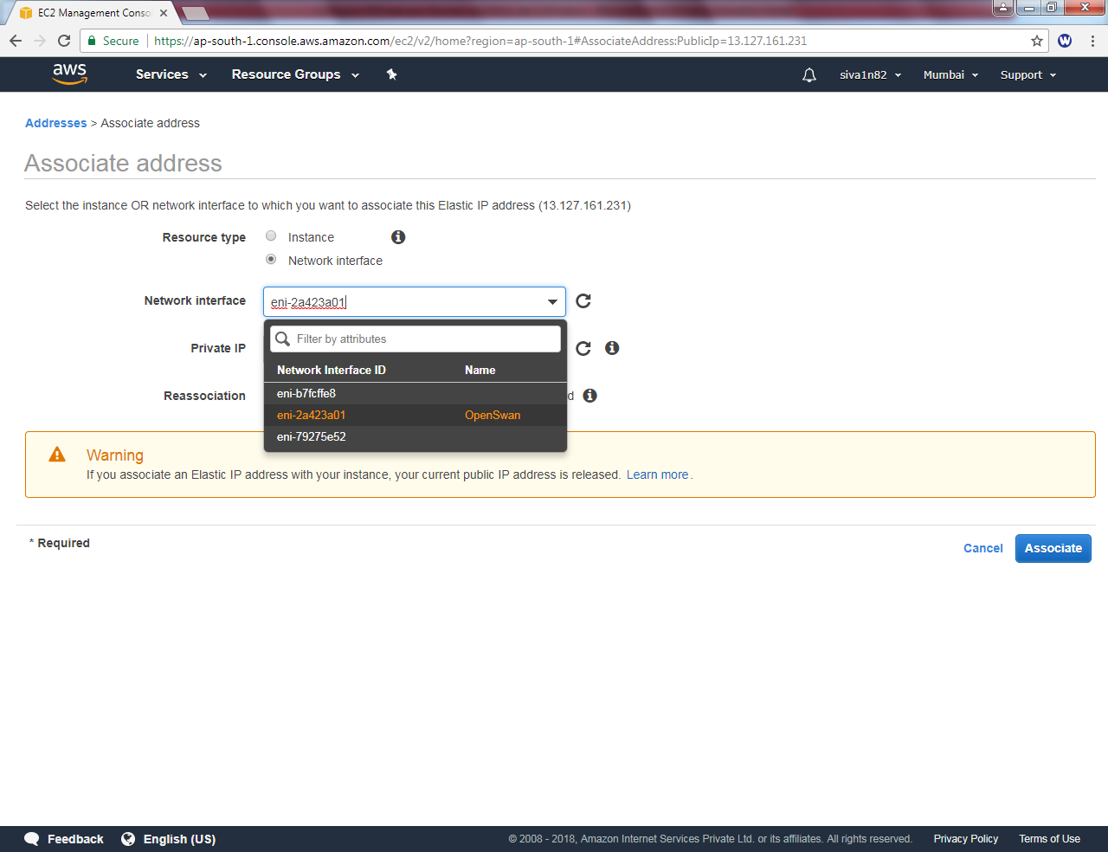

Select Private Ip address andclick “Associate”.

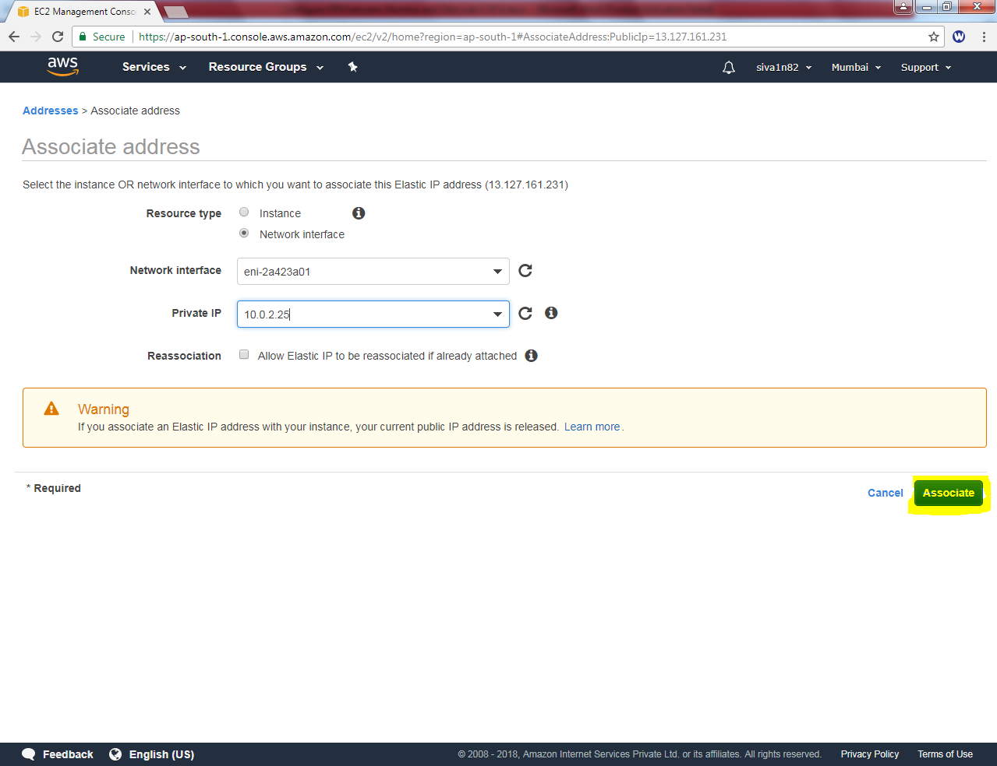

Associate address request succeeded.

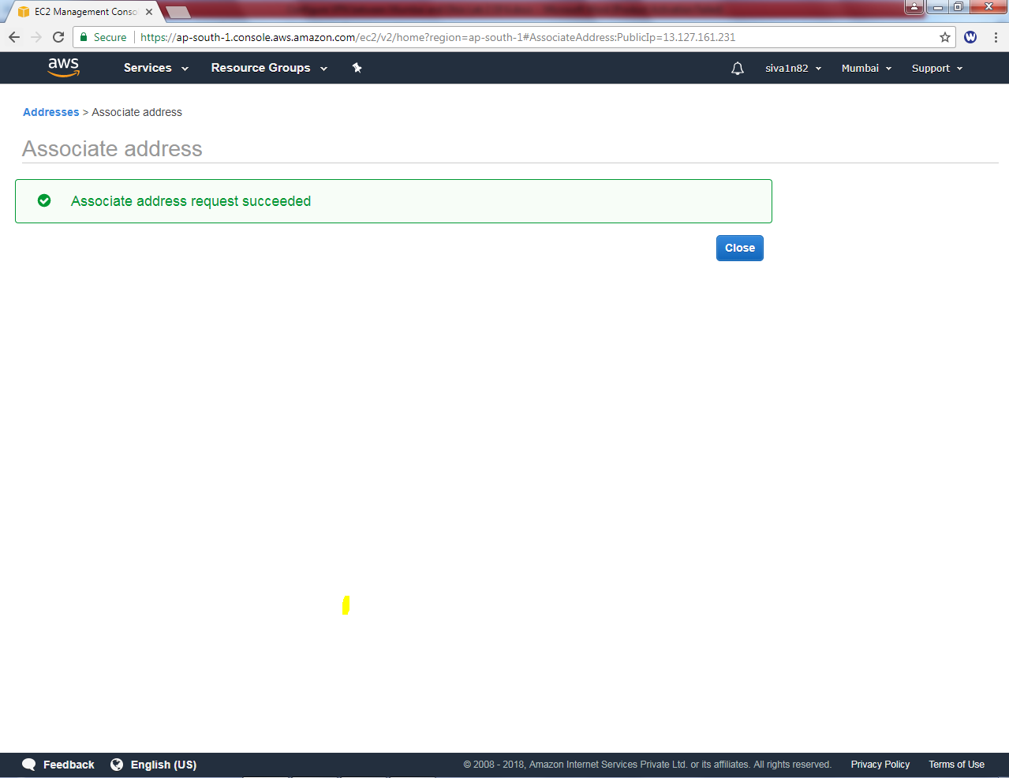

Now the interface has been assigned with public ip address.

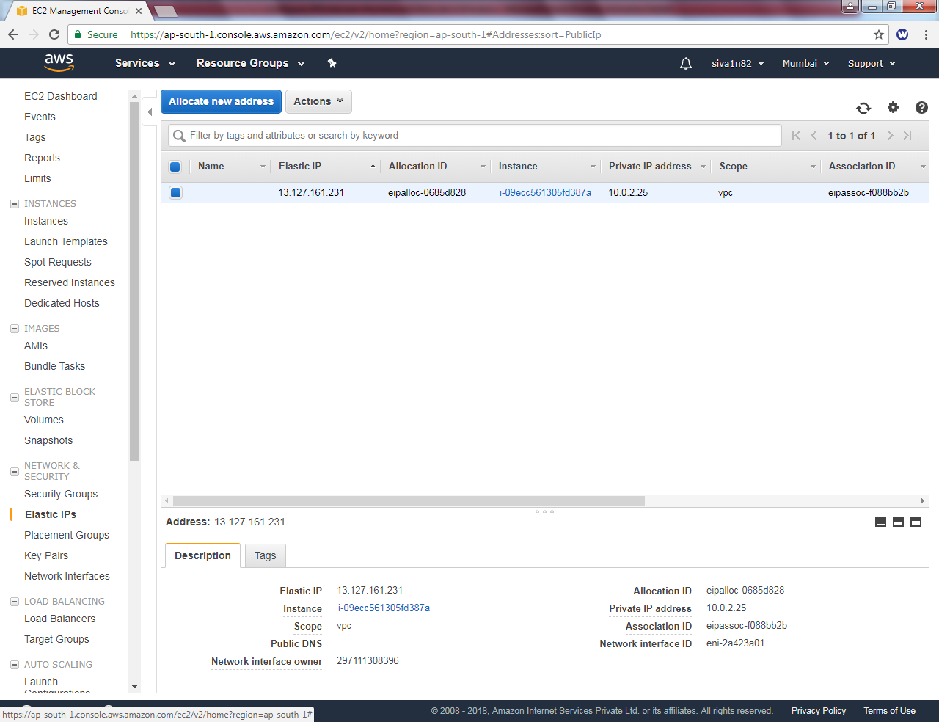

Go to Ohio region,

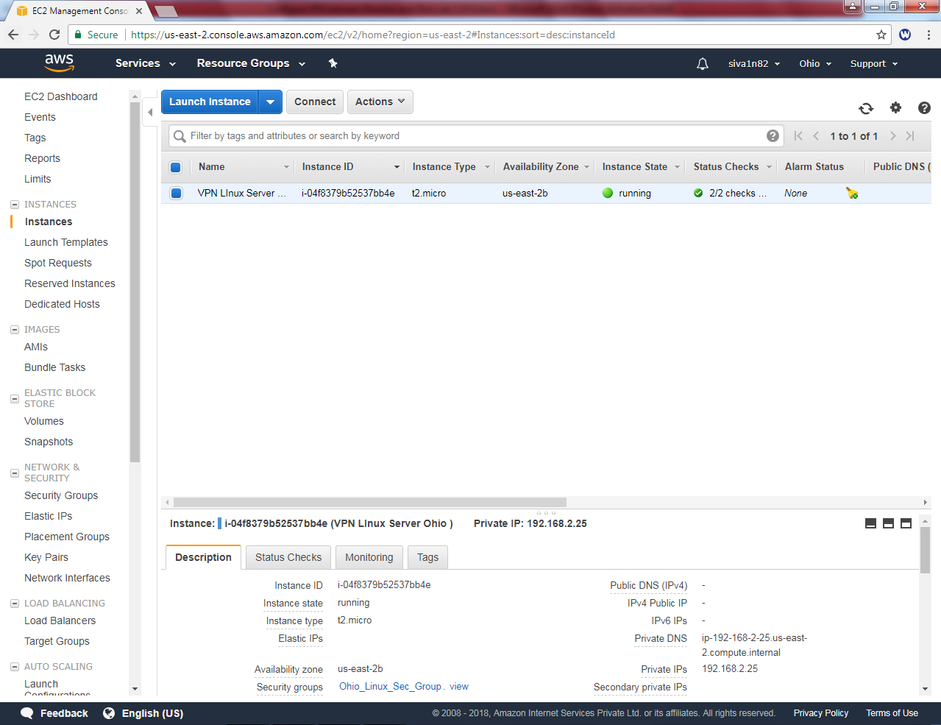

Rename the interface name as “Openswan”.

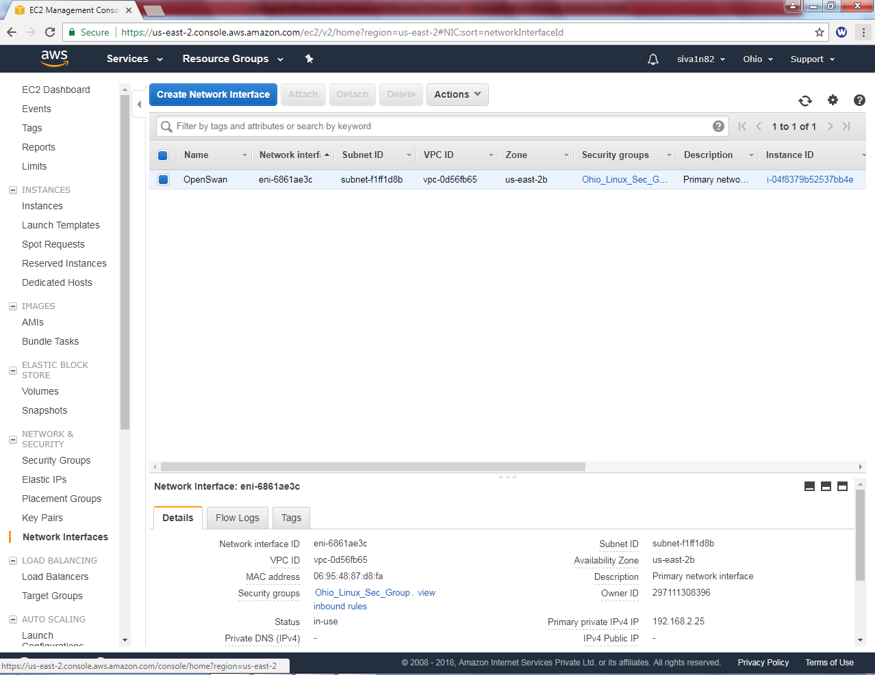

Click “Allocate new address”.

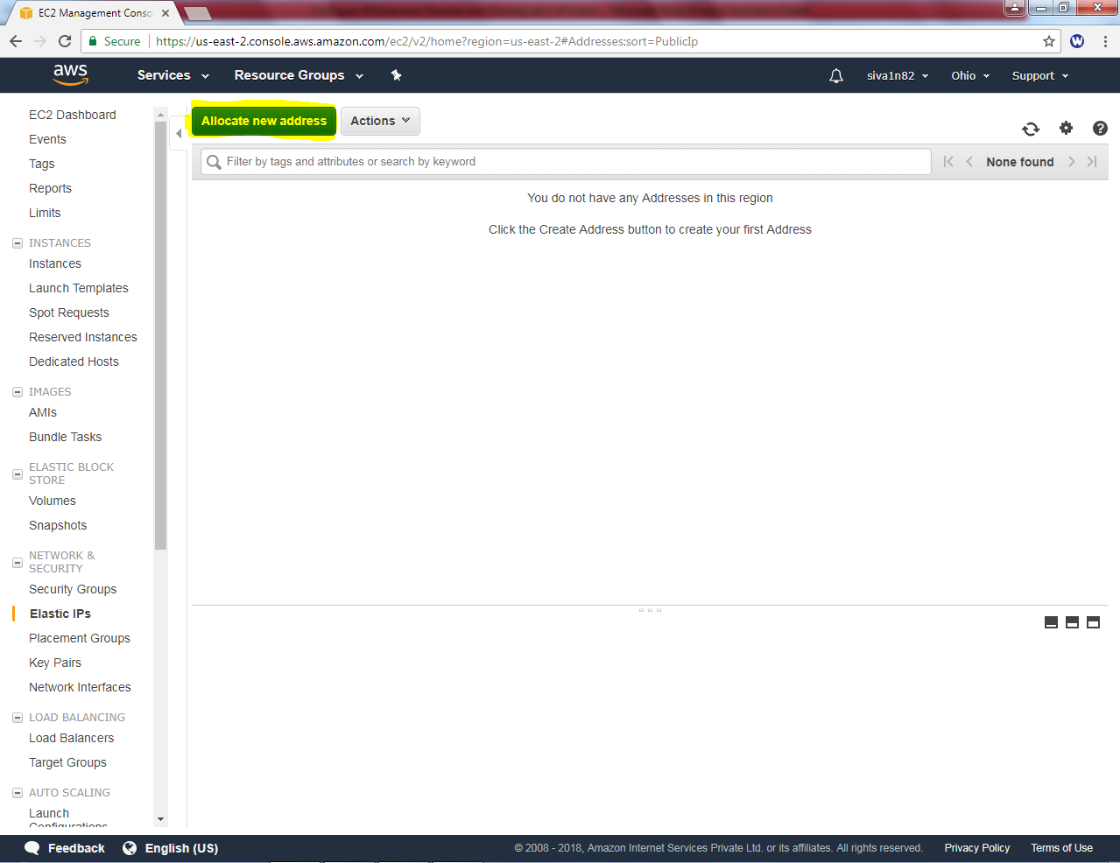

Click “Allocate”.

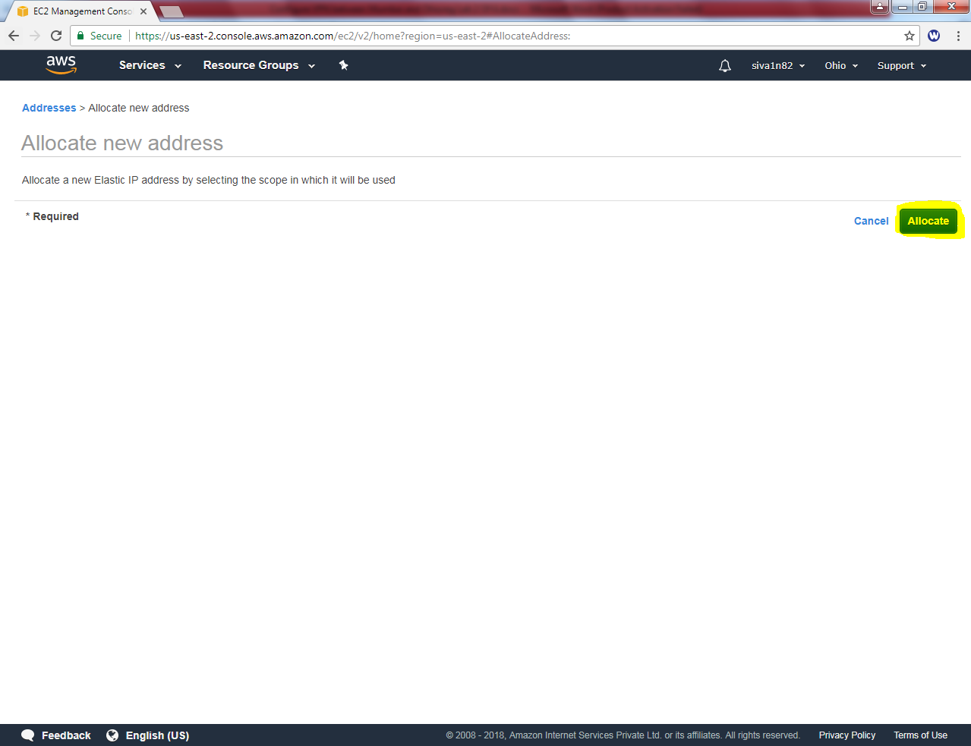

Elastic Ip has been provided.

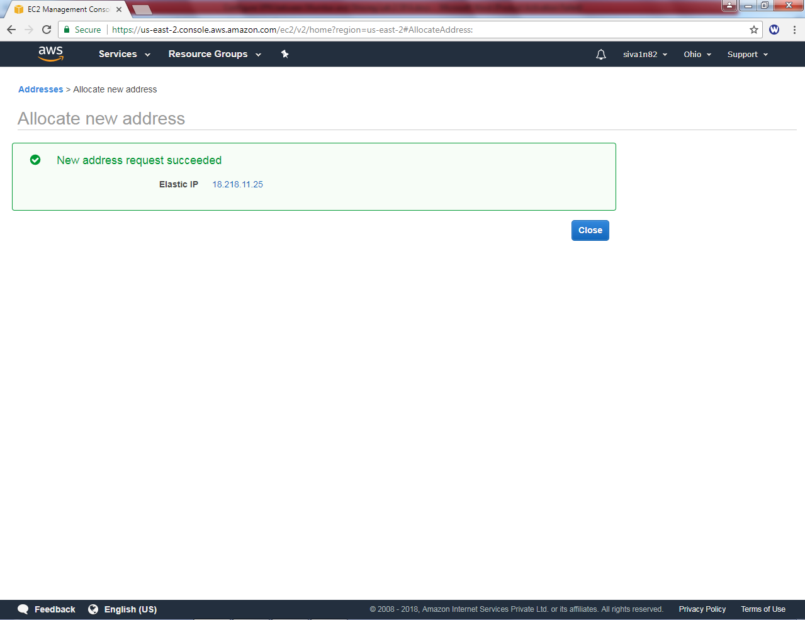

The IP address needs to be associated. Select the IP and right click and then select “Associate address”.

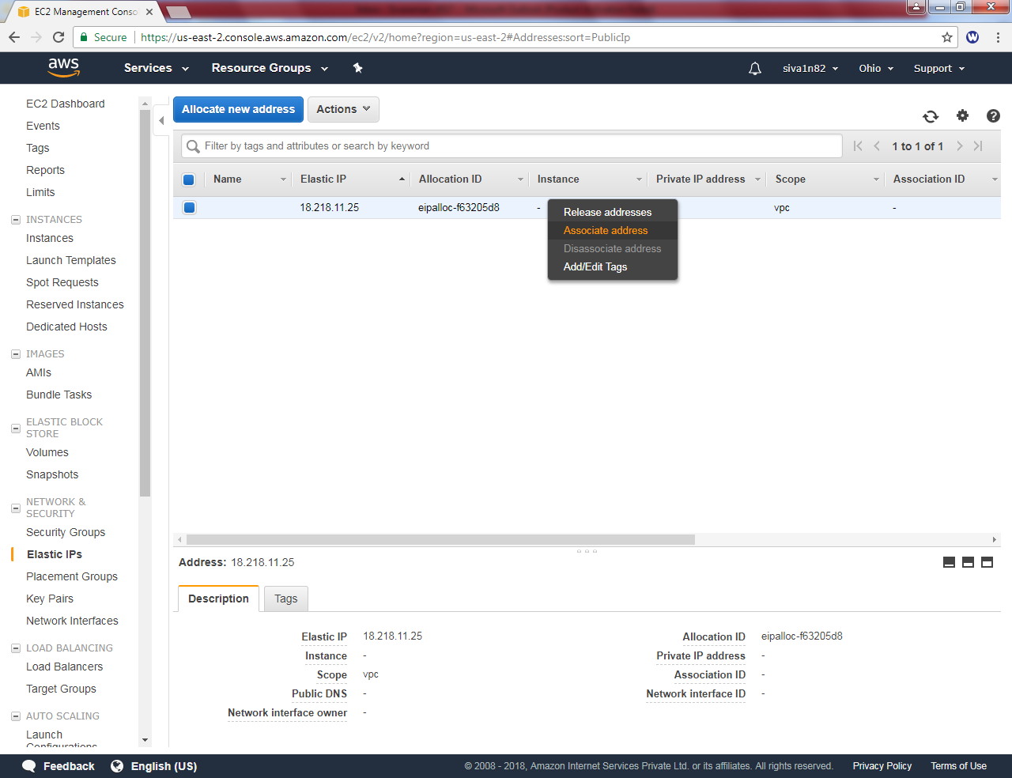

Select Resource type as “Network interface”, Select network interface and Private IP.

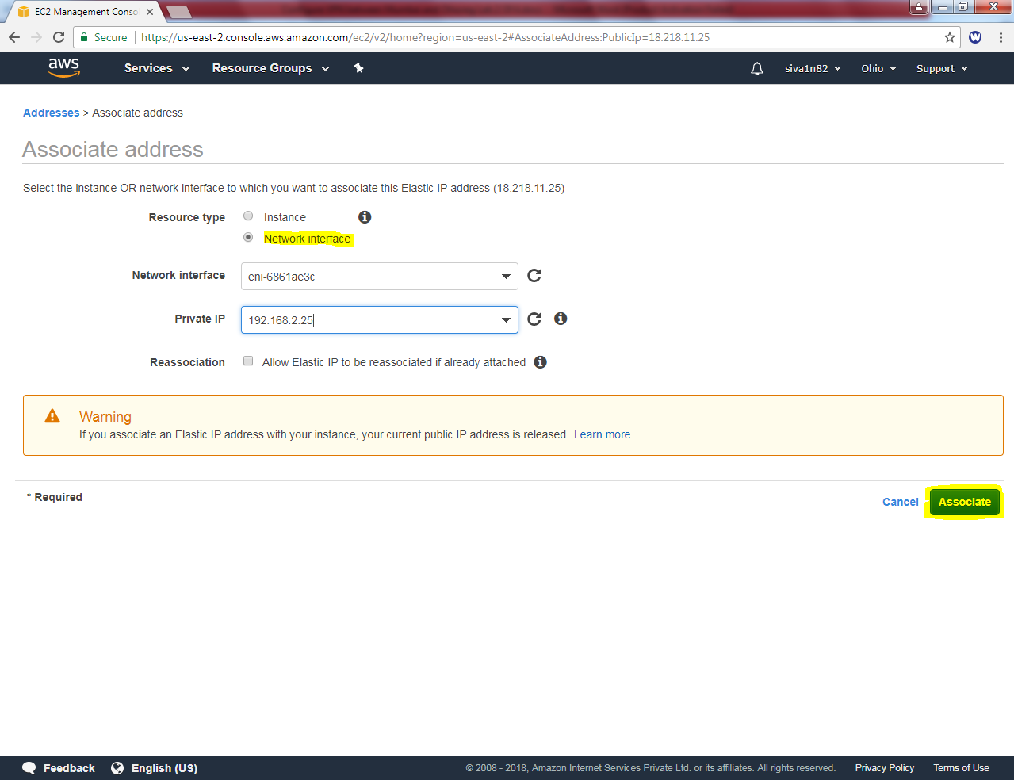

Click “Associate”.

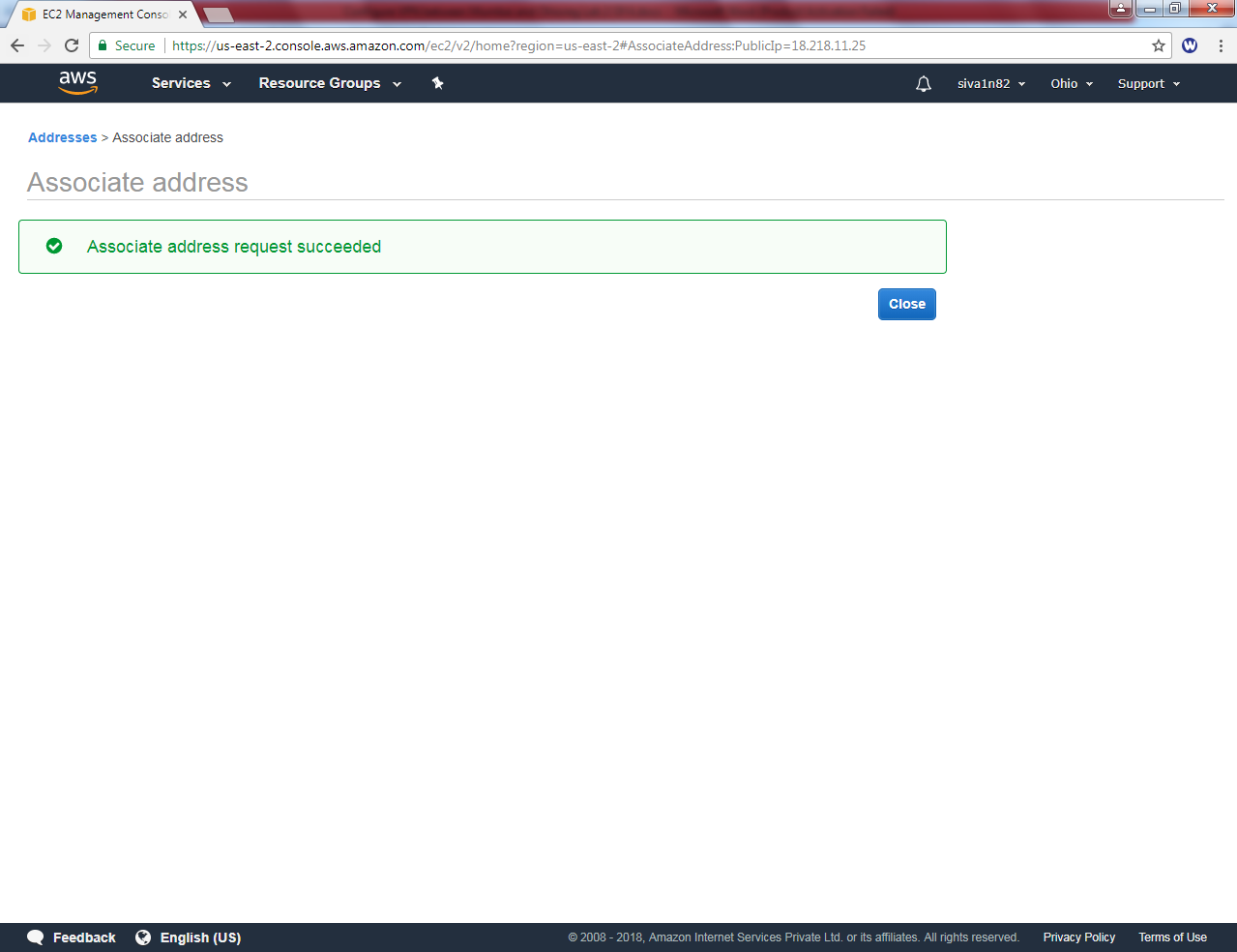

Now Elastic ip has been assigned to interface.

